It is important that our checkout cart is as flexible as possible. We will have a large number of single-product landing pages (on a single store or on multiple stores) and will need to be as parameter-driven as possible.

The desired behavior of the Shopify App is that when we click on the app, we are presented with a screen to adjust the fields displayed on the checkout page.

<https://checkout.trybrightology.com/flamebritetest/flame/checkout?comments=true&faq=true&proof=top&timer=true&sticky=true&language=us&hitid=932761036561541549>

**HEADER SECTION**

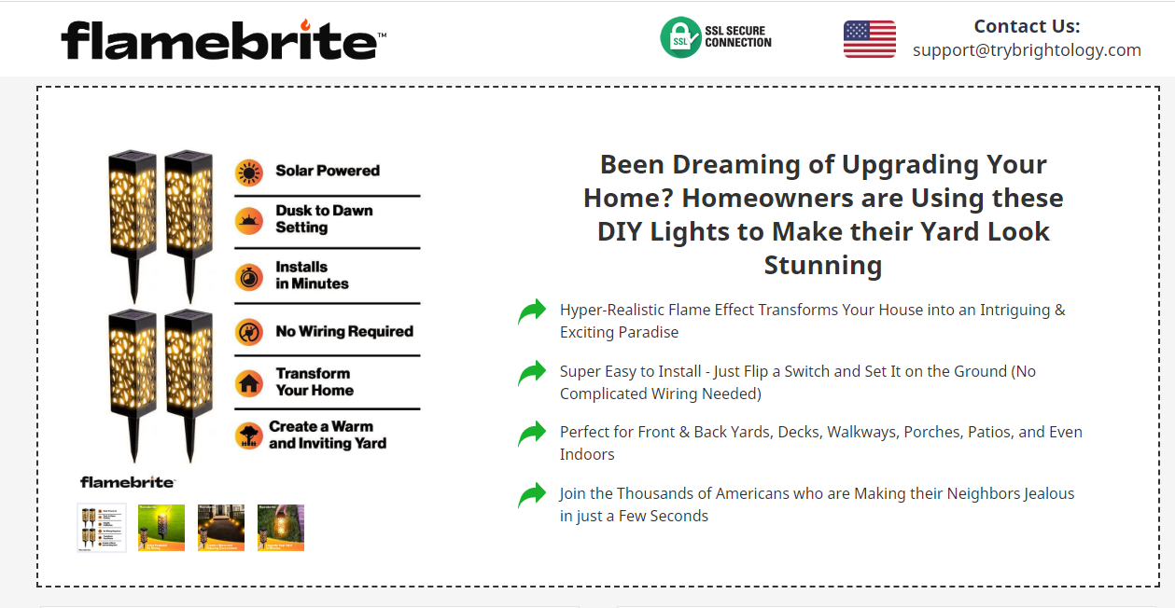

1. Would you want this portion built using a CSS sheet for each product?

**PRODUCT SELECTION SECTION**

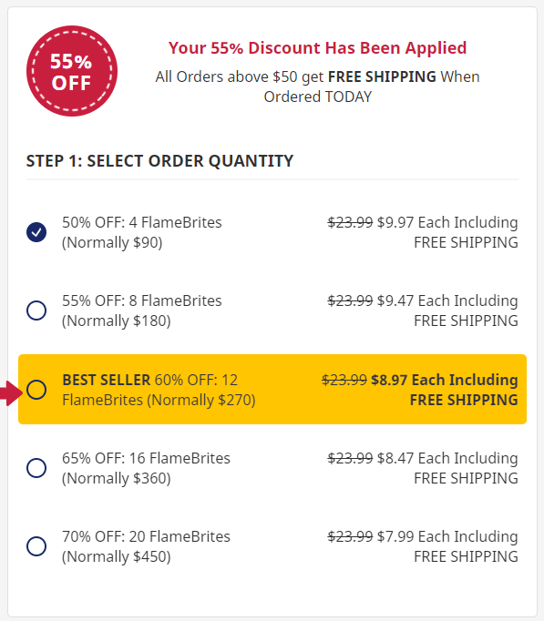

1. The graphic that says “55% OFF” needs to be modified per product
2. The text next to it does as well
3. Their will always be 5 options to select from, but the text and color of the highlighted center one (always 3rd option) needs to be modified per product

**DATA STRUCTURE**

1. Do you want to store the data in:
   1. An XML File
   2. Shopify Meta Fields
   3. Something else?
   4. We need to be able to easily edit each parameter with each product having their own:
      1. CSS sheet name
      2. Savings Icon
      3. Savings Text
      4. Item 1 Qty, Left Text, Right Text, Amount
      5. Item 2 Qty, Left Text, Right Text, Amount
      6. Item 3 Qty, Left Text, Right Text, Amount
      7. Item 4 Qty, Left Text, Right Text, Amount
      8. Item 5 Qty, Left Text, Right Text, Amount
      9. Social Proof Image
      10. Order Bump Image
      11. Order Bump Headline
      12. Order Bump Text
      13. Button Color
      14. Button Text
      15. Under Button image
      16. Guarantee Image
      17. Guarantee text

**FAQ SECTION**

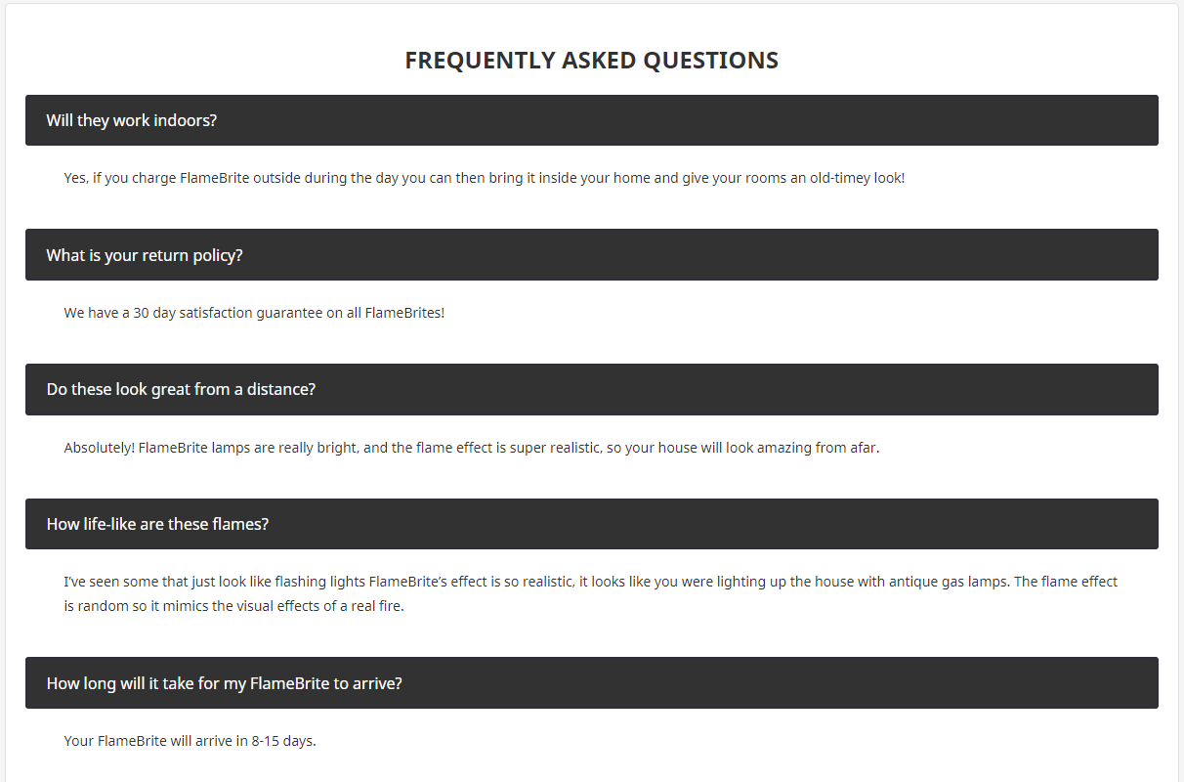

6. Do you want to put the FAQ in the same CSS file as the header or somewhere else?